Title | Data-Driven Design of Metal-Based immunogenic Cell Death Inducers
Proponent | Dr. Thomas Scattolin
Research Group | Applied Organometallic Chemistry (AOC)
Contact | web: https://organometallics.it
 | email: thomas.scattolin@unipd.it
Co-Proponent | Prof. Roberto Battistutta
Research Group | Biomolecular Structures
Contact | web: https://wwwdisc.chimica.unipd.it/roberto.battistutta
 | email: roberto.battistutta@unipd.it
International Secondment
PI | Dr. Pablo Nogara
Institute | Federal Institute of Education, Science and Technology Sul-rio-grandense (IFSul)
Place, country | Bagé, RS, Brazil
# months (min.3) | 4

Project description (2 page max):

Immunogenic cell death (ICD) is a form of regulated cell death capable of eliciting an immune response against dying cells. ICD is characterized by the release of danger-associated molecular patterns (DAMPs), which include molecules such as calreticulin, ATP, and high mobility group box 1 (HMGB1). These molecules function as immunostimulatory signals, activating antigen-presenting cells and promoting an adaptive immune response. Given its ability to enhance anti-tumor immunity, ICD has emerged as a promising strategy in cancer treatment.¹ However, to date, no established design principles exist for the development of efficient ICD inducers, limiting their rational discovery and optimization. Preliminary studies by the Principal Investigator (PI) have demonstrated that organopalladium complexes can effectively induce ICD in cancer models.² Encouraged by these results, this project aims to extend the study to a broader range of transition metal complexes, investigating the correlation between their stereoelectronic properties and their ability to trigger ICD. The ultimate goal is to establish structure-activity relationships (SARs) that will guide the rational design of novel and efficient ICD-inducing metal complexes.
The project will focus on the synthesis of a diverse library of transition metal complexes, including but not limited to palladium, platinum, gold, and ruthenium complexes, featuring a variety of ligands with distinct steric and electronic properties. By systematically modulating ligand properties, the project aims to explore their influence on the biological activity of the corresponding complexes. The synthesized metal complexes will be tested for their ability to induce ICD in high-grade serous ovarian cancer (HGSOC) models, the most common and aggressive subtype of ovarian cancer, often characterized by late diagnosis and poor prognosis. Current treatments rely heavily on platinum-based chemotherapeutics, which show limited efficacy due to resistance mechanisms. The ability of the metal complexes to induce ICD will be assessed by measuring the release of key DAMPs (calreticulin exposure, ATP secretion, and HMGB1 release) in vitro and ex vivo. These studies will be conducted in collaboration with the Department of Pharmaceutical Sciences (Prof. Valentina Gandin) and the CRO of Aviano (Prof. Flavio Rizzolio).
A key innovation of this project is the exploration of structure-activity relationships using advanced statistical and machine learning techniques. The stereoelectronic properties of the ligands will be quantified using parameters such as Tolman Electronic Parameter (TEP), buried volume (%V_{bur}), and bite angle, etc.³ The relationships between these descriptors and ICD induction (as assessed via DAMPs release) will be analysed using multivariate statistical approaches and machine learning models. This approach will enable the prediction of more potent ICD inducers and provide a framework for the rational design of next-generation metallodrugs. The most effective ICD-inducing metal complexes will undergo in-depth mechanistic studies to understand their stability and potential off-target interactions by assessing their reactivity with biologically relevant molecules such as glutathione. Given that the primary molecular target of ICD-inducing metal complexes is often thioredoxin reductase (TrxR), an essential enzyme in cellular redox homeostasis and a promising target for metallodrugs due to its overexpression in cancer cells, the interaction between the selected metal complexes and TrxR will be studied using calorimetric techniques such as isothermal titration calorimetry (ITC) and X-ray crystallography. The production of recombinant TrxR enzymes and the structural characterization of the complexes with metallodrugs by X-ray crystallography will be performed in collaboration with the group of Prof. Battistutta, who will act as co-supervisor.
To complement the experimental work, a computational study will be undertaken to investigate the binding modes of the most promising metallodrugs with their molecular targets. Molecular docking simulations will be employed to predict interactions and provide a theoretical foundation for experimental findings. This part of the project will be carried out during a research stay at a leading international institution, fostering scientific exchange and broadening the training of the PhD student.
Overall, the establishment of predictive structure-activity relationships will enable a more rational approach to the development of ICD-inducing metallodrugs, bridging the gap between chemistry and immuno-oncology. Moreover, by focusing on high-grade serous ovarian cancer, the project aims to contribute to the development of novel therapeutic strategies for a malignancy with limited treatment options.
This PhD project aims to push the boundaries of metallodrug research by integrating synthetic chemistry, immuno-oncology, structural biology, and computational modelling (Figure 1). Through the establishment of robust design principles for ICD inducers, this research will provide a valuable framework for future developments in metal-based anticancer therapeutics.
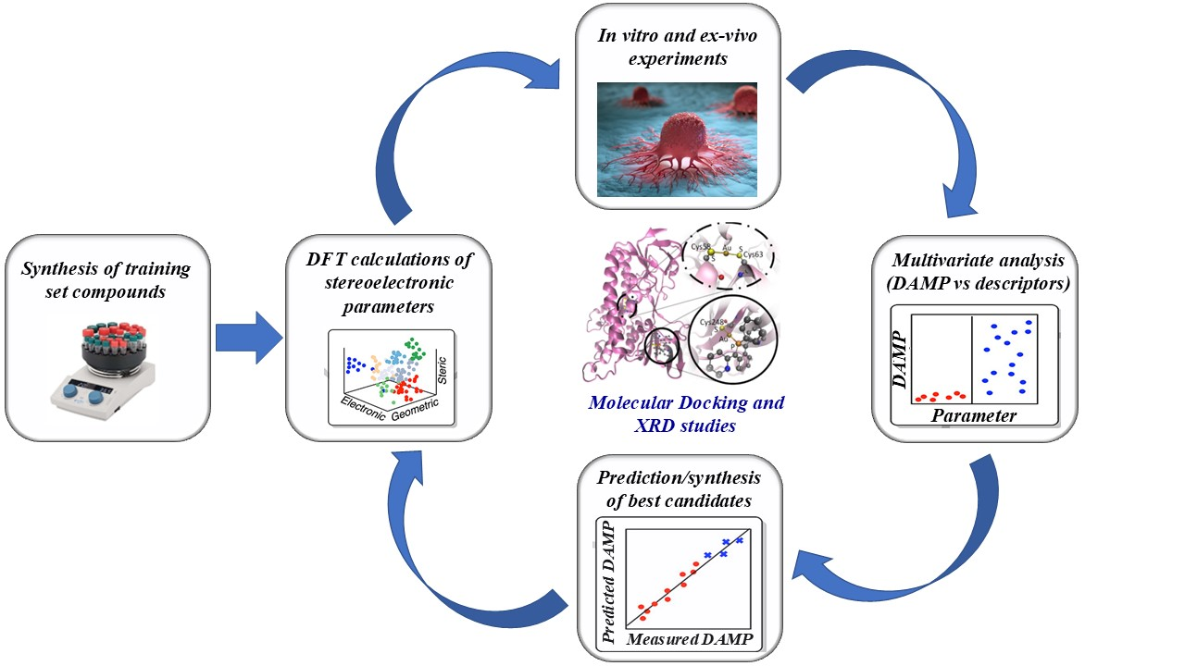
Figure 1. Key steps of the project

1. L. Zhang, N. Montesdeoca, J. Karges, H. Xiao, Angew. Chem. Int. Ed. 2023, 62, e202300662.

2. C. Donati, I. I. Hashim, N. B. Pozsoni, L. Bourda, K. Van Hecke, C. S. J. Cazin, F. Visentin, S. P. Nolan, V. Gandin, T. Scattolin, RSC Med Chem. 2025, DOI: 10.1039/D5MD00039D.

3. T. Scattolin, S. P. Nolan, Reaction Parameterization as a Tool for Development in Organometallic Catalysis in Comprehensive Organometallic Chemistry IV, Elsevier, 2022.

