Title | Synergistic Integration of Photochemical and Electrochemical Processes in Catalysis
Proponent | Marco Fantin
Research Group | Electrocatalysis and Applied Electrochemistry
Contact | web: | https://wwwdisc.chimica.unipd.it/electrochem/
 | email: | marco.fantin@unipd.it
Co-Proponent | Andrea Sartorel
Research Group | Nano & Molecular Catalysis
Contact | web: http://www.chimica.unipd.it/NanoMolCat
 | email: | andrea.sartorel@unipd.it
International Secondment
PI | Cyrille Costentin
Institute | Université Grenoble-Alpes
Place, country | Grenoble, France
# months (min.3) | 3-6

Project description (2 page max):
The proposed work aims to integrate a photochemical event and an electrochemical step within the same reaction pathway, thereby uncovering new pathways in synthetic chemistry. Inspired by nature's use of two visible-light photons to drive complex reactions in photosynthesis, we will instead introduce one photon and one electron (or hole) into a photocatalyst.

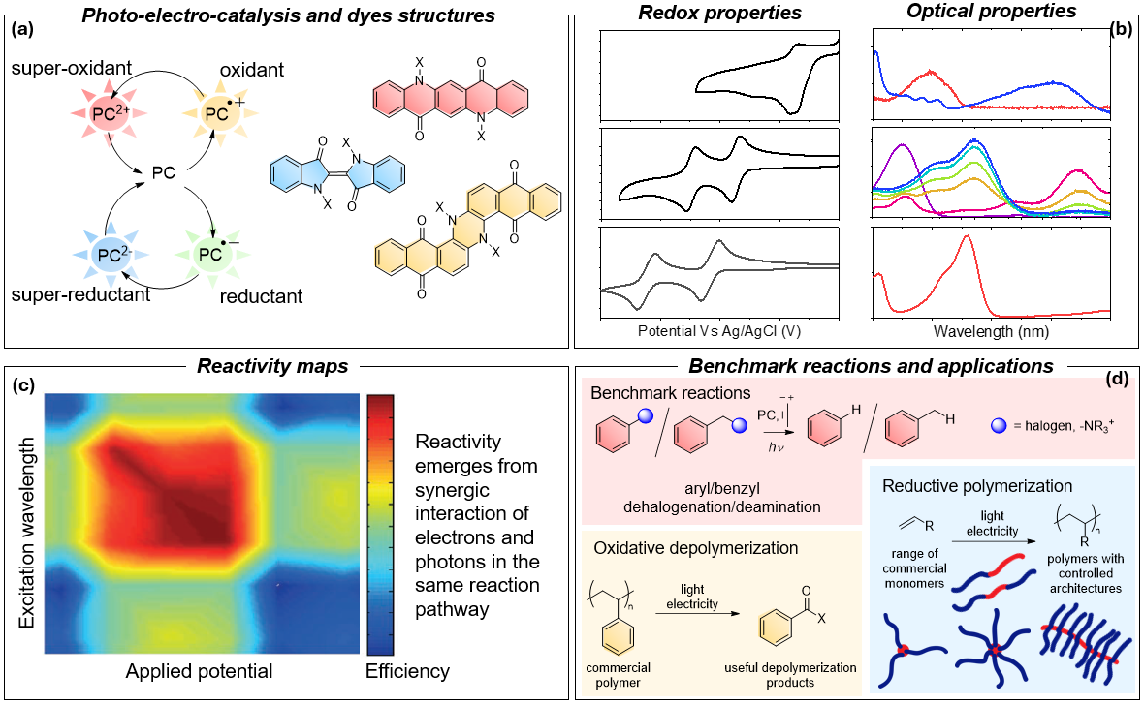
The integration of a homogeneous photocatalytic system into an electrochemical cell, termed electro-photocatalysis, will enable us to access photocatalysts with unprecedented high-energy levels (Figure A).
These photocatalysts, characterized by extreme redox potentials, will facilitate highly demanding chemical reactions (figure D). For instance, in the case of reduction, a redox potential exceeding -3 V will be reached, allowing the photocatalysts to achieve single-electron reduction of various challenging substrates.
Moreover, the high energy of the photocatalysts will be utilized to conduct depolymerization reactions, enabling the chemical upcycling of polymers into small molecule feedstocks as a method of plastic waste valorization. Challenging reductive polymerization reactions will also be targeted, with the aim of providing new strategies to build complex polymeric architectures.
The catalysts will be derived from the modification of inexpensive and readily available commercial dyes. We will thoroughly characterize the obtained photocatalysts using the techniques of organic physical chemistry. Our aim is to understand their reactivity in both photochemical and electrochemical spaces (Figures B-C).

