Title | Harnessing Chemically Fueled Regenerative Chemiluminescence (CFRCL) for Advanced Bioanalytical Applications: The ReLISA Project
Proponent | Prof. Alessandro Aliprandi (PA)
Research Group | Applied Organometallic Chemistry group
Contact | web: | https://www.organometallics.it/
 | email: | alessandro.aliprandi@unipd.it
Co-Proponent | Dr. Alessandra Zanut (RTDA)
Research Group | Analytical Chemistry and Nanoscience Group
Contact | web: https://wwwdisc.chimica.unipd.it/ACN/
 | email: | alessandra.zanut@unipd.it
International Secondment
PI | Professor Arben Merkoçi
Institute | Catalan Institute of Nanoscience and Nanotechnology ICN2
Place, country | Barcelona, Spain
# months (min.3) | 3 months

Project description (2 page max):
Electronically excited states have long played a fundamental role in electron transfer (ET) processes, particularly in solar energy conversion. However, the reverse process—utilizing chemical energy to generate excited states via ET reactions in solution—has received significantly less attention. While early studies from the 1960s demonstrated chemiluminescent systems based on aromatic luminophores and metal complexes, their reliance on harsh conditions, such as toxic oxidants or highly reactive reductants, severely limited their practical applications [1].
We introduce Chemically Fueled Regenerative Chemiluminescence (CFRCL) as a groundbreaking shift in luminescent systems [2]. Unlike traditional chemiluminescence, which is intrinsically irreversible, or standard regenerative chemiluminescence, which requires sequential redox steps, CFRCL enables the simultaneous coexistence of the luminophore, oxidant, and reductant within a self-sustaining dissipative chemical cycle. This novel system continuously generates light without requiring external optical or electrical excitation, relying solely on chemical fuels.
Beyond its fundamental significance, CFRCL presents transformative opportunities in bioanalytical applications. In particular, it offers a next-generation alternative to horseradish peroxidase (HRP)-based chemiluminescent immunoassays [3], which are widely used but have intrinsic limitations. As a protein, HRP is prone to denaturation from temperature fluctuations, pH variations, and exposure to organic solvents, reducing assay reliability. Additionally, some biological samples contain peroxidase-like activity (e.g., hemoglobin in blood), causing background noise and false positives. Furthermore, HRP-based assays typically detect a single target at a time, limiting their use in high-throughput or multiplexed applications.
The ReLISA Project: A Revolutionary Enzyme-Free Immunoassay
The ReLISA project aims to develop an enzyme-free alternative to HRP-based chemiluminescent immunoassays. Inspired by the fundamental principles of ELISA (Enzyme-Linked Immunosorbent Assay), ReLISA replaces HRP with a redox-active luminophore capable of undergoing continuous chemiluminescence cycling.
The project will focus on:
- Synthesis and characterization of CFRCL-active organometallic complexes as chemiluminescent labels (CLI).
- Development of an ELISA-inspired immunoassay (Fig.1), where a CFRCL-active luminophore replaces the HRP-conjugated secondary antibody. The assay will operate in a solution containing both an oxidant and a reductant, enabling the luminophore to undergo continuous redox cycling and generate persistent chemiluminescence, which can be detected using standard luminescence readers.
The system offers enhanced stability by preventing HRP degradation, ensuring more reliable and consistent assays. It also provides higher specificity, with no interference from endogenous peroxidases found in biological samples, leading to more accurate results. Additionally, the use of engineered luminophores enables multicolor CFRCL assays, allowing for the simultaneous detection of multiple targets.
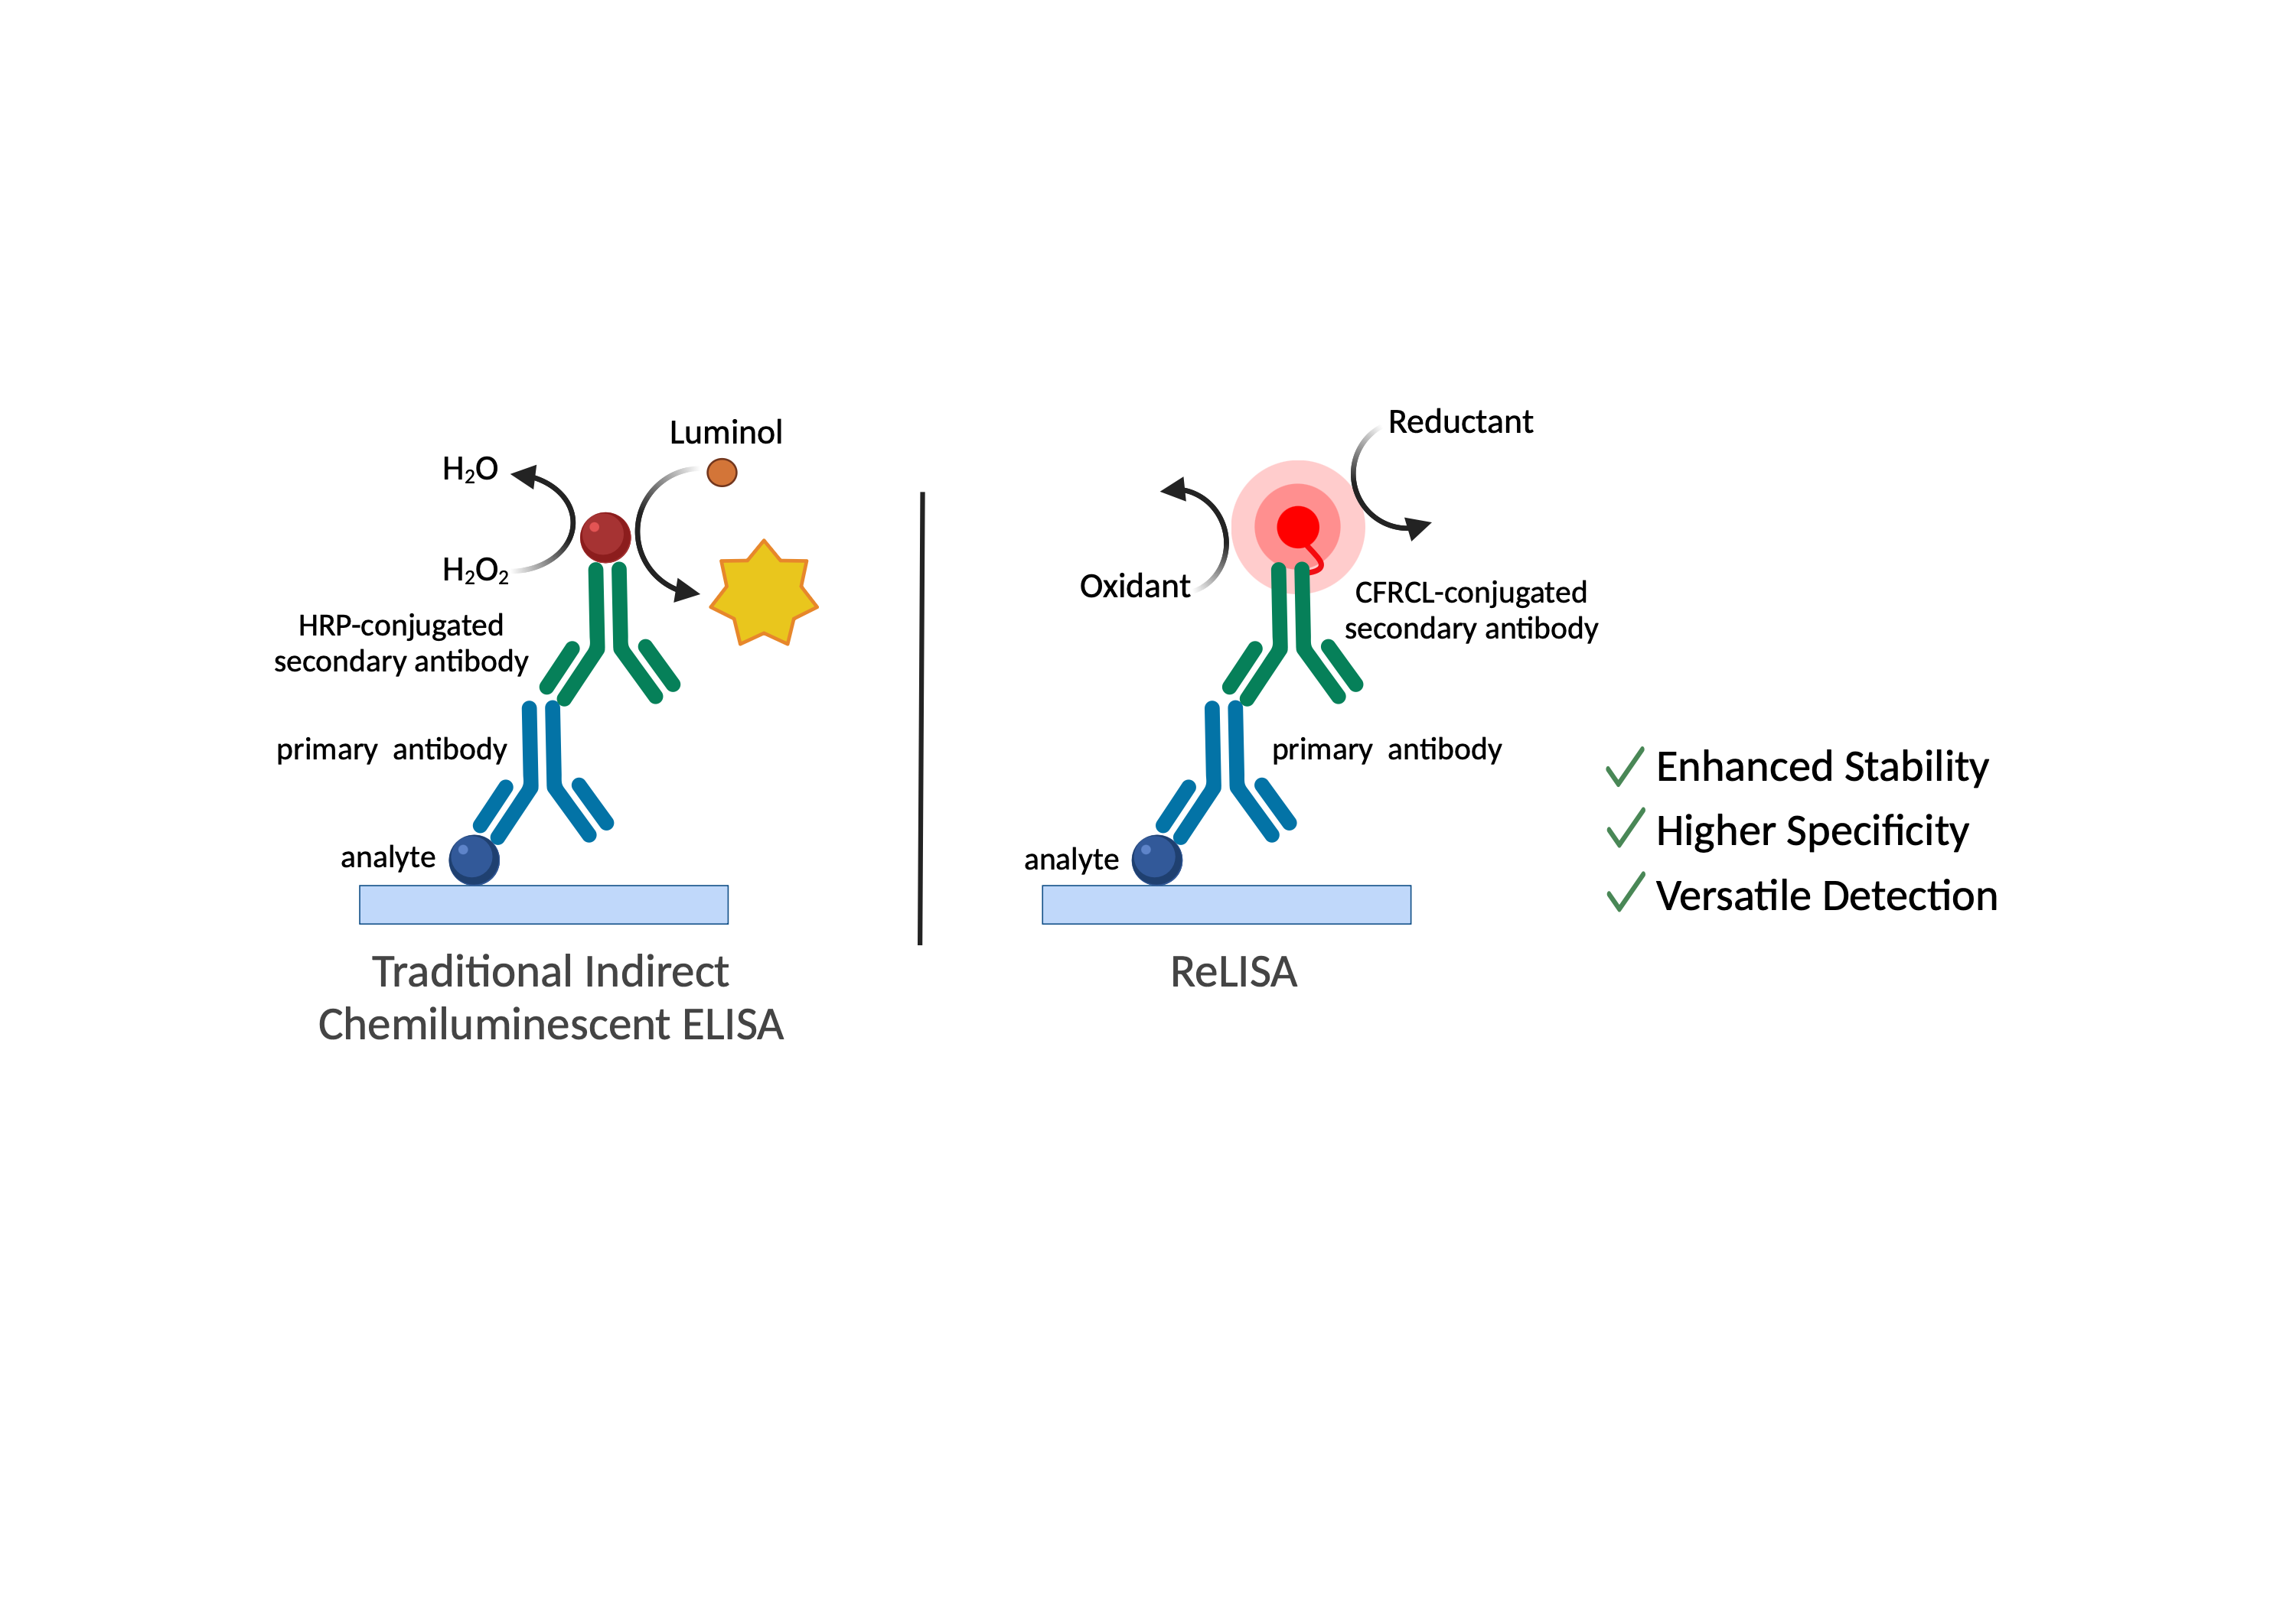
Fig 1. Schematic representation of ReLISA and its advantages.

By translating fundamental knowledge into a practical analytical tool with significant real-world applications, ReLISA has the potential to redefine bioanalytical detection technologies, offering advantages in sensitivity, stability, and multiplexing capabilities. This innovation may lead to commercialization opportunities in clinical diagnostics, environmental monitoring, and high-throughput screening. To this aim a secondment (at least 3 months) in the group of Prof. Merkoci is planned to integrate this technology in novel (bio)sensing tools.
A Unique PhD Opportunity in a Prestigious Research Environment
ReLISA doctoral project is inherently interdisciplinary, combining a synthetic chemistry approach with a wide range of advanced characterization techniques, including:
- Spectroscopic methods: NMR, UV-Vis, fluorescence spectroscopy (steady-state and time-resolved)
- Electrochemical techniques: Cyclic voltammetry, chronoamperometry
- Custom-built instrumentation: Optimized luminescence detection setups developed within the research group
The selected candidate will pursue a PhD within the esteemed Materials Science and Technology PhD program, as part of the Complex in Chemistry, C2 - Dipartimento di Eccellenza Project, hosted by the Department of Chemical Sciences (DiSC). This framework offers a stimulating scientific environment, providing access to international seminars, specialized courses, and collaborative research activities, fostering both technical expertise and professional growth.
By joining this project, the PhD candidate will engage in cutting-edge research at the interface of chemistry, materials science, and bioanalytics, contributing to the development of next-generation chemiluminescent technologies with broad scientific and industrial impact.

[1] C. Alberoni, G. Pavan, T. Scattolin, A. Aliprandi, ChemPlusChem 2024, 89, e202400142. https://doi.org/10.1002/cplu.202400142
[2] https://cordis.europa.eu/project/id/949087/it
[3] Cinquanta, L., Fontana, D.E. & Bizzaro, N. Chemiluminescent immunoassay technology: what does it change in autoantibody detection?. Autoimmun Highlights 8, 9 (2017). https://doi.org/10.1007/s13317-017-0097-2

