Title | Engineering the Interplay Between Hybrid Polyoxometalates and Proteins for Conformational Studies and Targeted Therapeutic Applications
Proponent | Mauro Carraro
Research Group | Hybrid Molecules and Materials
Contact | web: | https://wwwdisc.chimica.unipd.it/mauro.carraro
 | email: | mauro.carraro@unipd.it
Co-Proponent | Gabriele Giachin
Research Group | Biomolecular Structures
Contact | web: gabriele.giachin@unipd.it
International Secondment
PI | Annette Rompel
Institute | Institut für Biophysikalische Chemie, Fakultät für Chemie, Universität Wien
Place, country | Wien, Austria
# months (min.3) | 6

Project description

Introduction:
This study seeks to investigate the intricate interactions between polyoxometalates (POMs) and proteins, focusing on POMs with large polyanionic surfaces conjugated with organic molecules, to target specific proteins and promote innovative biomedical applications.
Polyoxometalates are molecular polyanionic metal oxides with a broad range of applications. In the biomedical field they are studied, among other uses, as anticancer drugs and to inhibit the bio-chemical events involved in the neurodegenerative diseases. Within this context, POM can establish multiple interactions (electrostatic, hydrogen bond, host-guest) with peptides, proteins and enzymes. The ability of POMs to interact with proteins stabilizing or modifying their structure, offers a unique opportunity to study the structure and function of these biomolecules, which are crucial for understanding their roles in diseases. Key therapeutic targets will include (i) protein PD-1 (Programmed cell death protein 1 precursor) – involved in multiple cancer treatment and (ii) the protein Tau (microtubule‐associated protein), which forms insoluble filaments that accumulate as neurofibrillary tangles in Alzheimer’s disease (AD) and related tauopathies.,

Objective:
This study will focus on the design of hybrid molecular species in which the organic and inorganic domains must cooperate in a controlled way to create a novel system with enhanced biological activity. On one hand, the interplay between the two covalently bonded regions of the POM must be weak to avoid competitive intramolecular interactions; on the other hand, cooperative supramolecular interactions should occur once the protein is recognized. By investigating these hybrid POM-protein interactions, we aim to expand our understanding of protein structure and function, both in structural studies and biomedical applications. Specifically, studying the POM-protein interface could open new avenues for targeted drug delivery, enzyme inhibition, and the development of innovative nanomedicines that modulate protein function (Figure 1).
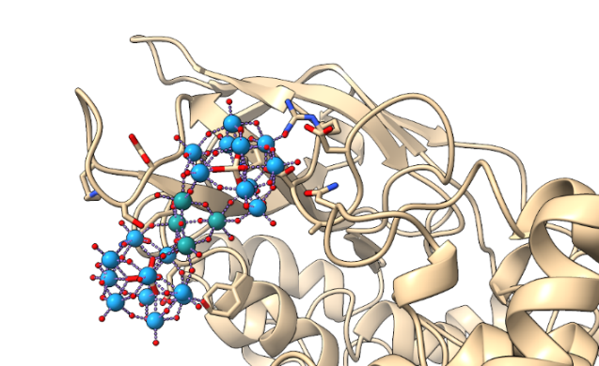
Figure 1. Molecular model of the interaction between a Ru₄-based polyoxometalate and the human ACAD9 protein.

Given the intrinsic complexity of the hybrid POM-protein assemblies (arising from the interplay between covalently linked inorganic clusters and organic targeting moieties, and from the establishment of multiple non-covalent interactions at the biomolecular interface) structural resolution at near-atomic level becomes essential. To achieve this, cryo-Electron Microscopy (TEM/Cryo-EM) will be used as an innovative tool to provide insights into the morphology of the complexes and the localization of the POM. Cryo-EM is uniquely suited to address this challenge, as it enables the visualization of heterogeneous and flexible macromolecular complexes in near-native conditions. These experimental insights will be complemented by molecular docking and molecular dynamics simulations, which will provide atomistic models of the interaction landscape and elucidate the conformational plasticity and energy profiles associated with POM-induced structural transitions. The integration of cryo-EM data with computational modeling is thus crucial to dissect the emergent structural complexity and functional implications of these supramolecular systems.

Methodology:
The PhD student will employ the following methodologies:
- Synthesis of Hybrid POM-Protein Complexes: selected POMs will be conjugated with targeting moieties such as peptides, antibodies, or small molecules. During the period in Vienna, the PhD student will perform the synthesis and characterization of novel hybrids belonging to the family of Anderson-Evans POMs, for which A. Rompel is a widely recognized expert.
- Expression, purification, and sample preparation of protein targets for cryo-EM: recombinant expression systems (e.g., E. coli) will be employed to produce target proteins such as PD-1 and Tau, including engineered domains optimized for structural studies. Purification will be performed using affinity and size-exclusion chromatography.
- Molecular Docking Simulations: simulations will be used to predict the binding affinities of the POM-protein complexes and identify the specific binding sites on the proteins.
- Electron Microscopy (TEM/Cryo-EM) will be used to investigate the structural characteristics of the POM-protein complexes at the nanoscale. Data acquisition and initial screening will be conducted using the cryo-EM instrumentation available at the University of Padua, while high-end data collection and processing will be carried out through access to national cryo-EM infrastructures
- Thermodynamic Studies: Isothermal calorimetry will be used to investigate the enthalpic and entropic contributions to the binding interactions.
- Spectroscopic Characterization: A combination of UV-Vis, NMR, circular dichroism (CD), and fluorescence spectroscopies will be employed to monitor conformational changes, binding stoichiometry, and the structural dynamics of the protein upon binding to the POMs.
- Functional studies: locking or inhibition of proteins and enzymes will be studied by specific biochemical assays.

V. A. Zamolo, G. Modugno, M. Carraro et al. Selective Targeting of Proteins by Hybrid Polyoxometalates: Interaction Between a Bis-Biotinylated Hybrid Conjugate and Avidin Front. Chem. 2018, 6, 278
Fabbian S., Giachin G., Bellanda M., Bonchio, M.; Carraro, M.; Battistutta R. et al. Mechanism of CK2 Inhibition by a Ruthenium-Based Polyoxometalate Front. Mol. Biosci. 2022, 9, 906390.
McDermott DF, Atkins MB. PD-1 as a potential target in cancer therapy. Cancer Med. 2013, 2, 662-73.
Medeiros R, Baglietto-Vargas D, LaFerla FM. The role of tau in Alzheimer's disease and related disorders. CNS Neurosci Ther. 2011, 17, 514-24.
Viola G., Giachin G., Assfalg M. et al. Conformational signatures induced by ubiquitin modification in the amyloid-forming tau repeat domain. PNAS 2025, in press
Carraro M., Giachin G., et al. unpublished results

