|  |  |  |
| --- | --- | --- |
| **Title** | **Electrochemically aided, gold promoted chemical transformations (ELECTROGOLD)** | |
|  | | |
| Proponent | Prof. Andrea Biffis | |
| Research Group | Applied Organometallic Chemistry | |
| Contact | web:www.organometallics.it |  |
|  | email: andrea.biffis@unipd.it |  |
| Co-Proponent | Prof. Sara Bonacchi | |
| Research Group | Molecular Electrochemistry and Nanosystems | |
| Contact | web: | |
|  | email:  sara.bonacchi@unipd.it |  |
|  | | |
| **International Secondment** | | |
| PI | Prof. Bruce Arndtsen | |
| Institute | Chemistry Department, McGill University | |
| Place, country | Montreal, Canada | |
| # months (min.3) | 6 | |

**Project description (2 page max):**

Gold chemistry has witnessed remarkable developments over the last decades, enabling the synthesis of various gold-based structures, from nanoparticles with controlled size and shape to atomically precise nanoclusters and to mono- and polynuclear gold complexes. Extensive research has been conducted to evaluate the properties of these species for potential applications in different fields, such as catalysis, sensors, materials, and medicine.

When gold is downsized to the nanoscale, or further down to nanoclusters exhibiting small gold cores, or even to mononuclear gold species, the redox properties undergo significant changes: while massive gold exhibits inertness, gold nanoparticles become catalytically active for technologically relevant redox processes like CO, glucose, or alcohol/diol oxidation. However, when the size is further reduced to just a few atoms or mononuclear gold complexes, the catalytic versatility in redox processes becomes significantly waning due to decreased stability arising from changes in electron valence. Additionally, redox chemistry with mononuclear gold complexes is hindered by the relatively low stability of the +3-oxidation state, making it challenging to attain from the more common gold(I) compounds.

In the ELECTROGOLD project, the **training-through-research** aims at integrating complementary approaches across synthetic nanostructures/inorganic complexes and electrochemistry to **go well beyond the state of the art** and overcome the inherent difficulties in harnessing redox chemistry with these compounds through skilled electrochemical techniques. By using an electrical current instead of chemical means for oxidation/reduction, indeed, reactive intermediates will be rapidly and efficiently generated. These reactive intermediates can then participate in further reactions before decomposition, triggering chemical transformations of other species in solution and regenerating the initial gold compound, thereby closing an electrochemically activated catalytic cycle. This strategy has been actively pursued in recent years for various systems, including organic molecules, coordination compounds, organometallic complexes, and organic/inorganic materials, leading to efficient and sustainable electrosynthetic methodologies (stoichiometric and catalytic) for academic and industrial chemists.

In particular, the ELECTROGOLD project will take advantages of this sound background and will involve:

i) the design, synthesis, and characterization of two classes of gold compounds i.e., molecular gold nanoclusters and gold(I) complexes;

ii) iterative design optimization of these gold compounds thought an in-depth analysis of their electrochemical properties and stability as a function of skilled selection of ligands stabilizing the gold species.

iii) the use of these electrochemically activated redox processes into reaction sequences involving electron transfer and/or energy transfer to other species in solution, with concomitant regeneration of the starting gold compound.

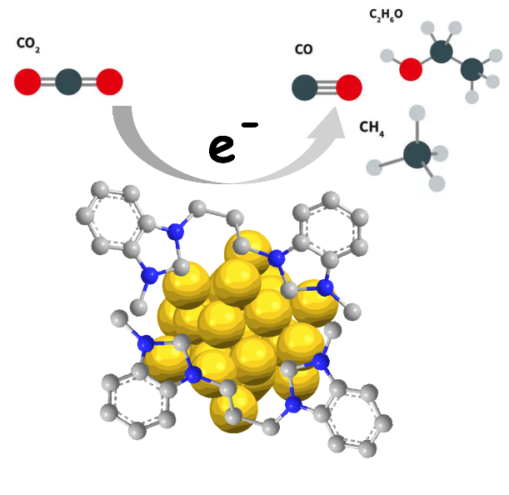

The ELECTROGOLD project is a *truly interdisciplinary project* combining synthetic ability and state-of-the-art electrochemical/electrocatalytic studies to develop highly active electrocatalysts. The PhD student will receive training in various experimental synthetic approaches under the supervision of Prof. Andrea Biffis (supervisor) who possesses 25 years of experience in applied organometallic chemistry and catalysis with late transition metals, and Prof. Sara Bonacchi (co-supervisor) who has and extensive experience in photochemistry, electrochemistry, and nanoclusters. Moreover, the PhD student will also have the opportunity to collaborate with groups experienced in similar electrochemically triggered systems, such as Prof. Bruce Arndtsen's group in Montreal (Canada), who has developed synthetic strategies of this kind based on the palladium(II)/palladium(IV) manifold.

Finally, the candidate will be a PhD student at the *prestigious Molecular Science PhD school* within the framework of the Complex in Chemistry, *C2 - Dipartimento di Eccellenza Project* - Department of Chemical Sciences, DiSC - which will allow the candidate to improve his/her scientific background by attending international seminars, different courses, and activities.