Title | Complex Copolymer Compositions for Non-Immunogenic Alternatives to Poly(ethylene glycol)s
Proponent | Edmondo M. Benetti
Research Group | Laboratory for Macromolecular and Organic Chemistry
Contact | web: | https://wwwdisc.chimica.unipd.it/MOC/
 | email: | edmondo.benetti@unipd.it
Co-Proponent | Fabrizio Mancin
Research Group | Supramolecular Chemistry and Functional Nanoparticles
Contact | web: https://wwwdisc.chimica.unipd.it/fabrizio.mancin/pubblica/index.htm
 | email: | fabrizio.mancin@unipd.it
International Secondment
PI | Bruno De Geest
Institute | University of Ghent
Place, country | Ghent, Belgium
# months | 6

Polymer brush-based shells are commonly applied on nanoparticles (NPs) to ensure their stabilization within physiological environments, and to provide desirable pharmacokinetics by prolonging their blood circulation times. Poly(ethylene glycol)s (PEGs) have been traditionally the material of choice for generating brush shells that stabilize NPs and provide to them stealth properties within protein-rich media. However, serious concerns over the immunogenicity of PEGylated therapeutics are on the rise and have stimulated researchers to explore alternative solutions [1,2].
In particular, the application of PEGylated drugs can lead to varying levels of anti-PEG antibodies (APAs), potentially compromising the clinical effectiveness of treatments [3] and causing severe immune reactions to patients [4,5]. Recent studies have shown that SARS-CoV-2 mRNA vaccines based on PEGylated lipid nanoparticles (LNPs) contributed to boost APA generation in a significant fraction of individuals [6]. In addition, more than 70% of people who have never received PEGylated therapies were found to present pre-existing APAs presumably due to the widespread exposure to PEG-based additives present in food and cosmetics [7].
In response of the urgency for providing non-immunogenic alternatives to PEGs, poly-(2-alkyl-2-oxazoline)s (PAOXAs) and poly-(2-alkyl-2-oxazine)s (PAOZIs) have emerged as starting polymers for the formulation and functionalization of drug vehicles and, more generally, biomaterials [8].
PAOXA and PAOZI can be conveniently synthesized by cationic ring-opening polymerization (CROP), which is a highly controlled polymerization method giving access to a variety of different homopolymer and copolymer formulations through mild reaction conditions [9]. Despite the high potential of PAOXAs and PAOZIs, molecular parameters linked to biocompatibility are not fully understood. In addition, PAOXAs/PAOZIs are typically non-biodegradable, whereas the enchainment of heterocycles different from cyclic imino ethers during CROP could lead to the incorporation of hydrolysable/biodegradable functionalities.
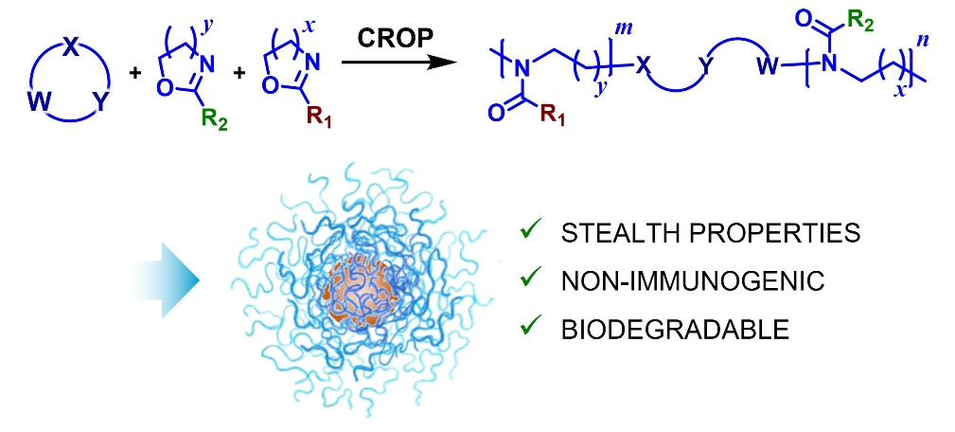
Inspired by these standing challenges, this PhD project will focus on copolymerization of different monomer species to generate PAOXA/PAOZI copolymers with improved biopassivity and diverse functional character. A library of copolymers will be obtained through combinatorial approaches in order to optimize (i) hydrophilicity/hydrophobicity balance, (ii) side chain functionalities, (iii) biodegradability/bioresorbability.
The structure and composition of the copolymers, their (bio)degradation and their interaction with relevant physiological media will be comprehensively characterized through a variety of techniques, including NMR spectroscopy (one- and two-dimensional), size exclusion chromatography (SEC), thermogravimetric analysis (TGA), high-performance liquid chromatography (HPLC), fluorescence spectroscopy, and quartz crystal microbalance with dissipation (QCM-D). A six-month visiting period at the University of Ghent under the supervision of Prof. Bruno De Geest will be aimed at integrating selected copolymers in drug delivery formulations and mRNA vaccines.
Precise tuning of CROP parameters and co-monomer composition will give access to a new class of polymers that will find application in the development of drug delivery systems, mRNA therapies, cosmetics and personal care products.

References
[1] Shi et al., Adv. Drug. Del. Rev. 2022, 180, 114079;

[2] Chen et al., ACS Nano 2021, 15, 14022;
[3] Ibrahim et al., J. Control. Release 2022, 351, 215–230;

[4] Shi et al., Adv. Drug. Del. Rev. 2022, 180, 114079;

[5] Bigini et al., Nat. Nanotech. 2021, 16, 1169

[6] Ju et al., Nat. Rev. Immunol. 2023, 23, 135;
[7] Yang et al., Anal. Chem. 2016, 88, 11804;
[8] Lübtow et al., J. Am. Chem. Soc. 2017, 139, 10980;
[9] Verbraeken et al., Eur. Polym. J. 2017, 88, 451.

