Title | Hydrolytic nanozymes
PI | Fabrizio Mancin
Research Group | Supramolecular Nanochemistry and Advanced NMR
Curriculum | Scienze Chimiche
Location | Dipartimento di Scienze Chimiche
Contact | web: wwwdisc.chimica.unipd.it/fabrizio.mancin
 | email: fabrizio.mancin@unipd.it

Project description:
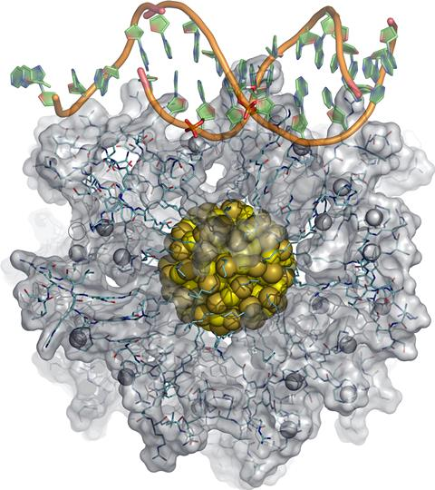
Nanozymes, i.e. nanoparticles reproducing enzymes' features (substrate recognition, reactants desolvation, transition state stabilization, multivalency and cooperativity) recently emerged as new catalytic species joining the benefits of chemical catalysts (robustness, low cost) and enzymes (selectivity, reactivity in mild conditions). Over the years, we acquired a solid experience in the design of nanozymes for the hydrolysis of phosphate esters, based on the cooperation of Zn(II) ions also with organic functional groups. Indeed, the nanoparticle’s coating monolayer can be considered as a three-dimensional array of organic molecules grafted to the particle surface. The functional groups implemented can provide the interactions for substrate recognition and the radial organization of the molecules on the particle
surface multiply the number of interactions and provide some degree of preorganization. In this project, we will move the reactivity toward the so far unchallenged hydrolysis of amide and esters and related materials. The basic idea is to realize multivalent nanoparticles capable to conjugate the oxyanion hole formed by the Zn(II) ions with strong nucleophiles featuring a low pKa (alpha-nucleophiles). Computer-aided design will be implemented to deal with the high complexity of these systems. Testing will be performed on model substrates and microplastics. Applications include waste degradation and recycling.

Hosting group(s) for the period abroad (tentative list, may change): Prof. Luca Salassa, Donostia International Physics Center, Prof. Nick Williams, Univertiy of Sheffield.

