Title | Probing composition/efficacy relationships towards effective delivery of nucleic acid drugs
PI | Margherita Morpurgo
Research Group | Pharmaceutical technology
Curriculum | Pharmaceutical Sciences
Location | Pharmaceutical Sciences Dept, Ed. A
Contact | web: | https://www.dsfarm.unipd.it/margherita-morpurgo-0
 | email: | margherita. Morpurgo@unipd.it

Project description
This project aims to develop knowledge and understanding on the structure and function of protein- based colloidal nanoparticles for effective intracellular delivery of nucleic acids.
Nucleic acids have emerged as promising biomacromolecules for combating a wide variety of infectious, immunological, and genetic diseases. To exert their activity, they must interact with their specific targets that are located within the cell in the cytosol or nucleus. However, naked nucleic acids cannot easily reach intracellular targets owing to their poor stability in the extracellular and intracellular environments and low intracellular uptake. Therefore, functional nanocarriers are required to protect them from degradation and improve their cellular uptake by endocytosis.
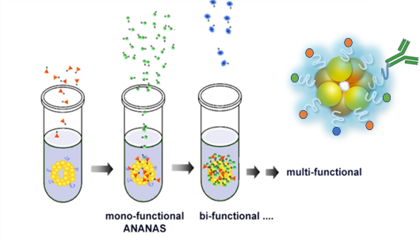
The Avidin Nucleic Acid Nano Assemblies (ANANAS) are nanosized (Ø = 120 nm) colloidally stable poly-avidin toroids generated from the condensation of a non-coding nucleic acid (NA) ﬁlament by the high-afﬁnity interaction with egg-white avidin. Thanks to the intact biotin-binding capability and the high afﬁnity for biotin ligands, ANANAS can be easily decorated at their surface, in one pot solution, with many functionalities (provided these can be biotinylated). This property allows us to modulate ANANAS surface composition with great precision and makes this platform an ideal tool for identifying relationships between NP surface composition and functionality. ^{1–6}
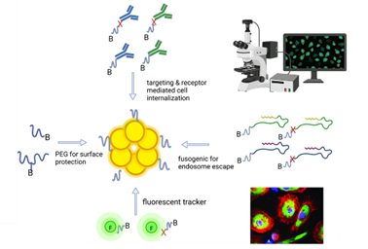
In this project surface-modified ANANAS with tunable functional and biological properties will be developed and characterized for their ability to interact with target cells and for their traffic within the different cell compartments.
Methodologies will be developed to understand how the nanoparticles interact with complex biological systems at cellular and subcellular levels and to probe the activity of the nucleic acids loaded onto them.
Expectd breakthroughs are the development of biodegradable nanotools, alternative to immunogenic and non-degradable petroleum-based lipid and polymeric nanoparticles, for nucleic acids delivery. In addition, we expect to develop a number of ‘nanoformulation rules’ which may serve as guidelines for the development of nucleic nanocarriers with different geometries than ANANAS. The versatility of ANANAS, combined to a nanoengineering multidisciplinary approach across chemistry and biology disciplines will be key to achieving this goal.

References
1 European Patent office, 20100197032, 2010.
2 M. Morpurgo, A. Radu, E. A. Bayer and M. Wilchek, Journal of Molecular Recognition, 2004, 17, 558–566.
3 F. Roncato, F. Rruga, E. Porcù, E. Casarin, R. Ronca, F. Maccarinelli, N. Realdon, G. Basso, R. Alon, G. Viola and M. Morpurgo, Nat Commun, , DOI:10.1038/s41467-018-06602-6.
4 M. Morpurgo, A. Buda, S. Facchin, E. Dassie, E. Casarin, M. A. Jepson, H. Neumann, S. Realdon, G. Hatem, R. D’inca’ and G. C. Sturniolo, Int J Nanomedicine, 2015, 10, 399.
5 M. Morpurgo, S. Facchin, M. Pignatto, D. Silvestri, E. Casarin and N. Realdon, Anal Chem, 2012, 84, 3433–3439.
6 P. Bigini, S. Previdi, E. Casarin, D. Silvestri, M. B. Violatto, S. Facchin, L. Sitia, A. Rosato, G. Zuccolotto, N. Realdon, F. Fiordaliso, M. Salmona and M. Morpurgo, ACS Nano, 2014, 8, 175–187.

