|  |  |  |
| --- | --- | --- |
| **Title** | **Surface Synthesized Carbene networks for electrocatalysis** | |
|  | | |
| Proponent | Stefano Agnoli | |
| Research Group | Interfaces and Nanomaterials for CATalysis (INCAT) | |
| Contact | web: | www.incatpadova.it |
|  | email: | stefano.agnoli@unipd.it |
| Co-Proponent | Cristina Tubaro | |
| Research Group | Applied Organometallics Chemistry | |
| Contact | web: www.organometallics.it | |
|  | email: | cristina.tubaro@unipd.it |
|  | | |
| **International Secondment** | | |
| PI | Tomasz Kosmala | |
| Institute | University of Wroclaw | |
| Place, country | Wroclaw, PL | |
| # months (min.3) | 6 | |

**Background and main research objectives**

Electrocatalysis is expected to play a key role in the energy transition toward renewable sources and to be an active player in the struggle against climate changes, given its potential to establish a virtuous chemistry/energy cycle, enabling an effective utilization of CO2 producing a variety of added value products [1,2] Despite the promising results on the lab scale and large gamut of proof of concept studies, many factors still hinder the practical implementation of the electrocatalytic route to CO2 conversion. One of the main hurdles is connected to the scarce activity and selectivity of the electrocatalysts used for the electrochemical CO2 reduction. Actually, the process of CO2 electroreduction is quite complex and involves several intermediates that can potentially give rise to differentiated final products. Such scarce selectivity is particularly detrimental for practical applications, because it implies complex electrolyzer and costly chemical work out. The limited activity and selectivity are intrinsically related to the many elementary steps associated with the CO2 electroreduction and the competition with the hydrogen evolution reaction, since water electrolytes are the most eligible media for practical applications and since it is highly desirable the introduction of hydrogen atoms in the final products (i.e. CH3OH, CH4, C2H4, etc.). Thence it is mandatory to address the problem of CO2 reduction at a very fundamental level, because only by the microscopic comprehension of the reaction, mechanism a rational design of new catalytic materials can be achieved.

DFT calculations and experimental data have clearly demonstrated that the most promising route to achieve superior performances is based on bifunctional effects, that is the combination/interaction of multiple reaction steps, since it consents a control of selectivity by steering the reaction path along the obtainment of select products and it allow escaping scaling laws.[3, 4, 5]

Normally, this approach is exploited with molecular catalysts by designing with great care the first, second, or even third coordination sphere around the catalytic sites. Unfortunately, such molecular materials are extremely expensive, little durable and difficult to implement on practical electrode. A solution to this problems is the bottom-up preparation of tailored molecular networks on metal surfaces through the protocols of the so called on-surface synthesis.[6] In this way it is possible to carefully control the reactivity of metal surfaces either creating surface metallorganic species with very reactive metal centers as well as “special reaction pockets” where the metal surface exhibit a chemical activity through because of a variety of interactions with the molecular overlayer. Quite recently, carbenes have emerged as possible building blocks for the formation of covalent molecular layers on metal surface leading to the formation of metallorganic species [7,8] or reaction pockets able to control the selectivity of electrochemical reactions such as the CO2 electroreduction [9,10].

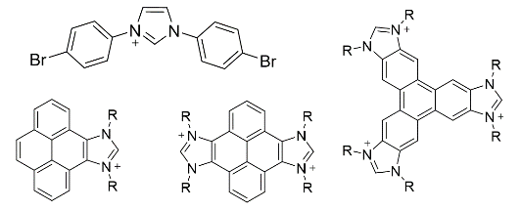**Methodology**

In collaboration with the Applied Organometallic Chemistry group, we propose to design carbenes with special functional groups (halogens, amines, carboxyls, etc ) poised for, on the one hand, a highly controllable surface polymerisation, and on the other hand, a precise design of the chemical environment around the single metal centers and metal surfaces (see fig.1). The preparation of on-surface synthesized monolayers will be carried out through a twofold approach:

Figure 1 examples of carbenes used as building blocks for the on-surface synthesis of covalent molecular networks

-under ultra high vacuum (UHV) conditions on Au(111) and Cu(111) single crystals, by a proper choice of the metal support, molecular precursor, coverage, temperature etc.

- by direct self-assembly at the solid/liquid interface, using different metal supports, solvents, etc.

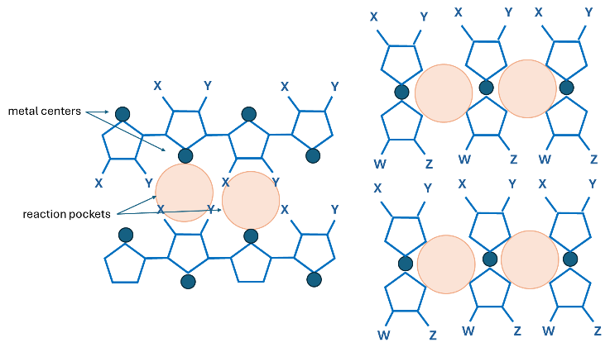The chemical and structural properties of the resulting layers will be investigated using all the techniques available at the INCAT group (XPS, UPS, UHV-STM, LEED, TPD etc). Their stability in electrochemical conditions will be tested in operando by electrochemical STM and in situ XPS. The part of self assembly at the solid/liquid interface will be carried out in collaboration with prof. T. Kosmala of the University of Wroclaw, who has a long experience in the preparation of molecular networks and their characterization by STM.[11,12]

The most promising molecular networks (highly ordered, robust and stable in electrochemical conditions) will be tested as catalysts for the electroreduction of CO2 using standard *ex situ* electrochemical methods (cyclic and linear sweep voltammetry, chronoamperometry, analysis of the reduction products by NMR and gas chromatography), and *in operando* by the new technique noise-EC-STM developed recently developed in the INCAT group [13].

Figure 2 Examples of the possible connectivity of carbenes for the formation of molecular networks of surface metallorganic species bearing active centers and reaction pockets

**Expected results:**

By preparing systems with different *chemical composition* (nature of the metal center/surface), and *tailored microenvironment* (first and second coordination around the catalytic center, side groups in the molecular precursors), and systematic investigating their structure and catalytic activity, we expect to understand:

1. what are the stable/durable/active phases during electrochemical reactions
2. the role of the metal/covalent network interface, which is endowed with special electronic properties and the main place where coadsorption of different species can take place and therefore representing the trigger
3. unravelling cooperative effects at different interfaces (metal surface/covalent framework, and in general the solid/electrolyte interface) and between different active sites (adjacent metal centers, reaction pockets, specific functional sides groups in the metal precursors and metal centers)

Given its unsurpassed spatial resolution (sub nm), the use of operando EC-STM will allow to identify with atomic scale precision all these “ensemble catalytic sites” and to evaluate directly and quantitatively their catalytic activity by the noise analysis method.[13] The gathered information can be used as a blueprint for the design of new catalysts for CO2 valorization.

**References**

[1] Nature Catalysis 4, 915–920 (2021); [2] [www.fch.europa.eu](http://www.fch.europa.eu)

[3] *ACS Energy Lett.* 3, 2816–2822 (2018) [4]Nature Catalysis 3, 775–786 (2020);

[5] Nature 529 68-71(2016) [6] Nat. Chem. 12, 115–130 (2020).

[7] Nat. Chem. 15, 1737–1744 (2023) [8] *J. Phys. Chem. Lett.* 2022, 13, 8, 2051–2056

[9] Commun Chem 6, 270 (2023). [10] Nat Catal 4, 352–363 (2021)

[11] J. Phys. Chem. C 2015, 119, 19228−19235 [12] *Top Catal* **61**, 1335–1349 (2018)

[13] Nature Catalysis 4, 850–859 (2021)